**Oral History Interview**

**with**

**Lavon Hightower Lewis**

Interview Conducted by

Tanya Finchum

August 4, 2016

Spotlighting Oklahoma

Oral History Project

**Oklahoma Oral History Research Program**

**Edmon Low Library ● Oklahoma State University**

**© 2016**

**Spotlighting Oklahoma**

***Oral History Project***

**Interview History**

Interviewer: Tanya Finchum

Transcriber: Madison Warlick

Editor: Tanya Finchum

The recording and transcript of this interview were processed at the Oklahoma State University Library in Stillwater, Oklahoma.

**Project Detail**

The purpose of the *Spotlighting Oklahoma Oral History Project* is to document the development of the state by recording its cultural and intellectual history.

This project was approved by the Oklahoma State University Institutional Review Board on April 15, 2009.

**Legal Status**

Scholarly use of the recordings and transcripts of the interview with Lavon Hightower Lewis is unrestricted. The interview agreement was signed on August 4, 2016.

**Spotlighting Oklahoma**

***Oral History Project***

**About Lavon Hightower Lewis…**

Lavon Hightower Lewis was born in Vinita, Oklahoma, in 1949 to Roscoe and Eunice Hightower. She attended public schools in Vinita and graduated from Vinita High School in 1967. At the age of fifteen Lavon began learning the skills of being a waitress when she went to work for the Hotel Vinita Coffee Shop. After a few years at the coffee shop, Lavon was hired by Annabell Southern to work as a waitress at the Glass House Restaurant on the Will Rogers Turnpike. She worked there the summer before attending Oral Roberts University (ORU). Lavon completed a year of college and due to a brief illness was not able to return for a second year. At that point she returned to the Glass House and worked there September 1968 until August 1969.

In 1969 Lavon moved to Okmulgee, Oklahoma, and lived there about seven years before returning to Vinita to live. In 1971, while in Okmulgee, she began a career with the phone company. Lavon would go on to retire from the phone company in 2003 after transferring to Tulsa and then to Vinita. With a thirty-two year career with the company, Lavon retired at the age of fifty-four.

Lavon married Mike Lewis, a high school sweetheart and employee of the Glass House, in 1980. They reside in Vinita and enjoy reminiscing about their earlier days working at the Glass House.

**About the Glass House…**

At the half-way point on the Will Rogers Turnpike near Vinita, Oklahoma, stands an iconic landmark. The arched building opened in 1957 and was the first restaurant built over a U.S. public highway. Conoco (Continental Oil Company) commissioned the building with an aim to serve the needs of motorists passing in both directions. The building housed the Glass House Restaurant, dedicated in 1958, and included a cafeteria, snack bar, and sit-down restaurant. On each side of the building, motorists enjoyed full-service gas stations, operated by Conoco initially. Over the years other restaurants and fuel facilities have operated at the service plaza. Host International, Interstate Hosts and Howard Johnson’s have operated the plaza at different times. The Glass House and the Conoco stations employed many of the area’s youth through the years and served many, many travelers. Renovation began on the service plaza in 2012 and in 2014 it re-opened with a new name, the Will Rogers Archway.

**Spotlighting Oklahoma**

***Oral History Project***

|  |  |
| --- | --- |
| **Lavon Hightower Lewis**  Oral History Interview  Interviewed by Tanya Finchum  August 4, 2016  Vinita, Oklahoma |  |

**Finchum** *Today is August 4, 2016. My name is Tanya Finchum. I’m with Oklahoma State University, and today I am in Vinita, Oklahoma, to speak with Lavon Hightower Lewis, and this is regarding Vinita’s Glass House Restaurant. So thank you for having us today.*

**Lewis** Thank you for letting me come today. It’s really an honor to be here. Working at the Glass House really was one of the highlights of my life as a young person. Of course there’s been other things more important, but that’s been very meaningful in my life. I just want to say right up front that I feel like my work at the Glass House prepared me for my career at the phone company, because when I left the Glass House I felt that I could work anywhere.

I had worked at the Hotel Vinita Coffee Shop for three years, with Mrs. Driskill as the manager, as a waitress. When I went to work at the Glass House, Annabell Southern, at the Glass House, and Mrs. Driskill worked together to change me from one place to another. They were good friends. I never applied for the job at the Glass House. Mrs. Driskill and Annabell did it because I was going to go off to college I know, and I could make more money in tips at the Glass House. I left the Hotel Vinita Coffee Shop one day and reported the next day to the Glass House. I’ve always thought that was so unusual. I never did ask Annabell about that. That must’ve been what they did, because they just told me to show up at the Glass House.

**Finchum** *No application, no interview?*

**Lewis** No. (Laughs) Of course the Hotel Vinita was comparable in menu and quality of service, and all that that the Glass House was. It was one of the best places in town to eat. The Grand Café was the other one that was our direct competitor. Then the Glass House, of course, was on the turnpike so it wasn’t exactly our competitor, but those two places were really great places to eat. You might say a little more high-class dining. On Sundays there we served on linen tablecloths, with linen napkins, real silver, and china.

**Finchum** *Just on Sundays?*

**Lewis** Yes, at the hotel, yes. Then we had nice serviceware during the week, but we didn’t use our linen tablecloths. We used paper napkins during the week. I think maybe in the evening, because we were open at the hotel in the evening until eight, probably for supper. I don’t think we had linen tablecloths. It was a little fancier because we had a full menu in the evening. It was comparable to the Glass House. I was originally trained then as a waitress at the Hotel Vinita Coffee Shop. I feel like that’s why Annabell then could accept me so easily, because she knew I already knew all the basics.

Then I had to be trained to Annabell’s way. Annabell was very tough, but she was very kindhearted and would just do anything for you. She was one that would roll up her sleeves and get her hands down in the dishwater, my husband said, because he was a dishwasher and busboy. She would get in there and show him how to do things. She was never afraid of work so she expected all of us to work as hard as she did. She wasn’t afraid to get down, dirty, doing anything. She was a wonderful boss to work for, but she was tough. She didn’t take much from anybody, but she was very kindhearted.

**Finchum** *And how old were you at that point?*

**Lewis** I was seventeen and then turned eighteen in July.

**Finchum** *So you started at the Grand Hotel earlier than that.*

**Lewis** At the Vinita Hotel, yes. I started when I was fifteen at the Hotel Vinita and walked to work because I wasn’t driving. It was about six or eight blocks to walk to work. I worked every afternoon after school five thirty to eight or until we cleaned up and then Saturdays and Sundays.

**Finchum** *Just because you wanted to or did your parents encourage you to?*

**Lewis** Yes and yes, Mother encouraged me too. One of my girlfriend’s mother called and told Mother about the job. I can remember Mom coming out and I was out in the garden and she came out and talked to me about if I wanted to go to work at the hotel as a waitress. That was a lot of fun and those were all wonderful days because—I think, even now my own children went to work when they were young teens and still in high school. I always encouraged that. I asked my daddy when he was going to buy me a car and he said, “You can get your car the same way I got it. You can just work for it.” That’s what I did. (Laughs)

**Finchum** *We should back up and ask, when did you graduate high school?*

**Lewis** In ’67, 1967.

**Finchum** *And from Vinita?*

**Lewis** Yes.

**Finchum** *Were you born and raised in Vinita?*

**Lewis** Yes, I was born and raised in Vinita. Went through Vinita schools and graduated. We have a little club of girlfriends from ’67, and we’ve added a few from ’68 and ’66, that we meet every few months to have lunch together. We had a class group of ninety-six people in our graduating class. We knew everybody in our class. We weren’t all friends and we weren’t all close, but a lot of these girlfriends I was in Campfire Girls and then Horizon Club with them. So we had that relationship all the way through. But I’ve told some of these same girls that I like them a lot better now than I did in high school, (laughs) because there’s so much that goes on in high school that really is not real life. Some people look back and hate the things that they went through in high school, and so they don’t want to have anything to do with the people they graduated with, but I think that’s kind of silly, because we’ve all become maybe better people than we were back then.

**Finchum** *Did you have a favorite subject in high school?*

**Lewis** My favorite was English. I was always straight As in English. I had a good grade point average, but I was always straight As in English. My senior year I took two English classes and one of them was creative writing. Mrs. Tyler was the teacher in that class and everybody just groaned and said, “It’s bad enough to have senior English with Mrs. Tyler, why would you take a second class?” I really loved her and I think she loved me.

Annabell and Mrs. Tyler were cousins, I think. They might’ve been sisters. I’m really not sure about their relationship, but they were close. They were related. I’ve given a lot of credit to Mrs. Tyler too, and I mentioned I write the devotional and it’s in five newspapers now. Some years ago, before Mrs. Tyler passed away, I saw her at the grocery store and we exchanged pleasantries as you do. I turned to walk away and she said, “Lavon, I’ve been meaning to tell you that I really enjoy your devotionals.” Oh, my gosh! I was just stunned that my high school English teacher would compliment me on my writing. That was really good for my ego.

**Finchum** *Didn’t say, “You need to work on your commas?”*

**Lewis** No. (Laughs) Commas are my thing! We have a real thing about commas. Of course I’ve learned a lot in the Christian writing group that I belong to in Tulsa.

**Finchum** *In high school had you planned—you mentioned college, what were you planning to do?*

**Lewis** English was my major. I went off a year after I worked that summer at the Glass House. I went off to ORU [Oral Roberts University] for a year. Scraped and saved all my money, and borrowed some, to go to ORU for the first year. Then I worked at another restaurant in town, in Vinita, because I did not go back and apply again at the Glass House or at the Hotel Vinita. They didn’t need anybody when I went to get a job. I worked that summer at the Deward and Pauline’s Restaurant, but I got stuck on nights. Deward and Pauline’s was a wonderful place, but of course on nights it was all of the people that worked nights, or truck drivers, or people that went out on Friday and Saturday night, and they’d come in half-drunk at four in the morning on Saturday or Sunday morning.

One man had a theory that if you ate a T-bone steak and drank a glass of buttermilk and coffee, you would get over being drunk without any hangover. I don’t know if it ever worked, (laughs) but that was a lot of fun. See those were things that we really didn’t deal with at the Hotel Vinita Coffee Shop or at the Glass House. I was so thankful for my experience because all of those things have made me who I am today.

The traits that I learned from the hotel and the Glass House were to be on time. That was one thing that would really get you in trouble is not being on time, because you were needed when you were supposed to be there. Tardies were frowned upon. You just didn’t call in sick. Unless you were really sick with something that you was contagious, that you could give to somebody else, you came on. There were lots of times that I worked with a headache and just pumped the coffee and kept going. Or the Pepsi, I really was not much on coffee, but Pepsi-holic back in those days.

I learned that being reliable, punctual, and showing up on time, and doing your things you were assigned to do. And I was never too good to do anything that I was asked to do. That meant if something happened and I had to mop the floor, then you just jumped in and did it. Those were the things that I learned being a waitress at those two places. Annabell had, and Mrs. Driskill at the hotel too, both had a real big impact on my life.

**Finchum** *It’s interesting that you call her Annabell and not Mrs. Southern.*

**Lewis** Yes, and Mrs. Driskill, her name was Gertrude, but nobody called Mrs. Driskill Gertrude. (Laughs) So that was the difference. I thought of that myself when I was going through preparing for this. That was the difference between Mrs. Driskill, the prim and proper, at that time she was probably sixty-five years old and I’m sixty-seven now, but then that seemed so old. Annabell was probably in her forties, thirty-five or forty. It really wasn’t an age difference. It was sort of a generational difference because Mrs. Driskill was prim and proper, and you spoke to her only when you had to, and you didn’t dare be sitting down when she walked in.

Annabell was more flexible. If you were sitting down taking your break when she walked in, she never paid any attention to it, but Mrs. Driskill would always question if you were really entitled to be sitting down, at that time, taking a break. We always worked hard for Annabell too. She wasn’t really like my girlfriend. I didn’t have that kind of relationship with her. In later years, when I knew her in town, we always had a wonderful friendship, but she wasn’t ever—I didn’t ever consider her my girlfriend when I worked for her. She was still my boss.

**Finchum** *Closer to your mother’s age?*

**Lewis** No, I don’t think she was even as old as my mother, but then my mother was about thirty-two when she had me. My mother just passed away in March at age ninety-eight. She had started working when she was sixteen, or maybe even before that, taking care of sick folks and doing different things. Then she lived out in the country and she came to Vinita. From then on she called herself a Vinitan, she lived in Vinita. She was from out there, but she lived in Vinita and Vinita was her home. In later years she would say, “You know I know everybody in Vinita.” And I’d say, “No, you don’t anymore, Mom.” (Laughs)

But Mother had worked as a maid and housekeeper for some of the rich ladies in town. So she knew the value of hard work. She expected all of us to do the same thing. She was a wonderful mother. She was always helpful and kind. Helped us when we were young mothers with our children. Lived away from town, both my sister and I especially, have lived with her at different times. So the last two years of her life then we were able to sit in her, take care of her in her home. Then with home healthcare and hospice we were able to keep her in her home until she passed away.

**Finchum** *Ninety-eight, that’s great.*

**Lewis** Yes, it was marvelous. I hope to live to ninety-eight and as well as she was. She knew who her girls were right up until the end.

**Finchum** *So there were just two of you?*

**Lewis** No. We have an older sister, Eddene, who’s six years older than me. She raised her family down at Broken Arrow, so she was away from here. She got married when she was seventeen. Now of course we’re close to her. We three girls are very close, and then our younger brother passed away about fifteen years ago. He had encephalitis and then died basically of a heart attack at age forty-six. He was really more well known in the city of Vinita than we were, because he was the assistant manager of Homeland, and before that, Safeway. So really everybody knew him and when I came back from living in Okmulgee for seven years, I told everybody I was Ross Hightower’s sister, because they didn’t know me anymore. There were four of us kids and we were raised here. Our dad worked out of town so we credit our mother with our good raising. Of course he had an impact too, but he worked for the railroad, and he was gone all the time.

**Finchum** *Hightower’s an unusual name, is that…*

**Lewis** Irish—or English. We’ve done lots of genealogy research. The Hightower goes back to England, but we have not ‘crossed the pond’ as they say it with Hightower, but we’ve done a lot of it. I’ve done the DNA with Ancestry, that was so fun, and I am 38 percent Irish, which is no surprise. I was red-headed, strawberry blonde, as a little kid and freckled faced. That was no surprise to hear that and then 25 to 30 percent Scandinavian. The TV show, Discovery Channel, TLC, one of them, has the show of the Vikings. Well the Vikings from Scandinavia came into England, and Ireland, and Scotland, invaded in the early year 1,000 or 1,100. I’m sure that’s where Scandinavian came from. Less than 1 percent Native American. I thought that was so fun, but that does prove our Native American link.

Our Grandmother Hightower, whose maiden name was Brock, was black-headed with black eyes. She claimed a quarter Cherokee, but they were never on the rolls. Then her two sisters at Stilwell both married Indian men. I thought, when we’d go down to visit them, I thought I was a little Indian girl too. (Laughs) We had a wonderful upbringing, and our mother taught us the value of work. I tried to instill that in my children and then now, as an adult, I think to myself, “I wonder if I trained my children to work too hard.”

My son is a service manager at a boat dealership over on Grand Lake. Then my daughter is a RN.

**Finchum** *Still some customer service in there, but in a different direction.*

**Lewis** Yes. I think everybody needs to know that even though we had hardships, and problems in our life, and things that we went through that we didn’t want to be doing while we were going through them, like when I moved to Okmulgee I had to take a job as a waitress again and I had a year-and-a-half of college. And I took typing, and shorthand, and I could do filing, and I did all of the bookkeeping, and all of those things, but nobody would hire me. My husband was going to tech school. I had to take another job as a waitress. I called crying to Mother, asking her to pray that I could find a job. Then I called her back crying because I had to take a job as a waitress. She said, “But Honey, you have a job.”

Then I found out in later years I had allergies, so I had coughing spells on the job. They had to let me go because I was coughing and the man said, “If the health department came in and you had a coughing spell, they could shut me down. You’re a good waitress, but I just have to let you go.” I called Mother again crying because I lost my job. (Laughs) I went to work then for the phone company while living in Okmulgee. I started there in ’71 and then retired in 2003.

**Finchum** *Was that before they made it split?*

**Lewis** Yes. In ’71 I worked on what we called the cord board in Okmulgee. That was where you picked out a cord with a metal end on it and plugged it into a hole with a light and said, “Operator.” This was after, “Number please.” “Number please” was before people got the opportunity to dial their own numbers, but we were long distance operators and directory assistance. I worked that in Okmulgee for three years and then in ’74 we all went to Tulsa and that’s when we got direct dialing, one plus and O plus dialing in ’71. They called it “rehoming” everybody to Tulsa. So Okmulgee and Claremore went the first shift—first group went to Tulsa and a carpool of us girls from Okmulgee started driving from Okmulgee to Tulsa every day, right in Downtown Tulsa.

Then I got a divorce in ’77 and moved back to Vinita to be close to our families. Then I started driving from here to Tulsa. So ten years altogether I drove to Tulsa from Okmulgee and Vinita. Then in ’84 I got one of the men’s jobs here in Vinita. Three old guys retired the same day and they put two people back in those jobs, so one of the old guys was a local man, well known, named C.J. Postier. The other one was Darry Daniels. Another man lived—he was from out-of-town. Darry Daniels passed away within a couple years after he retired, which was so sad. C.J. lived a long time. He would come into the office to visit. I’d tell him, “Three men retired and they only put two people back in, so one woman replaced two men.” (Laughs) We had a lot of fun with that.

**Finchum** *And it was typically a man’s job?*

**Lewis** Yes, it was. I worked with the dial tone equipment, the long distance equipment, and I’ve often said, “If I had any idea what I would go through in that nineteen years of my life, working that job, I would’ve never had the guts to do it.” But as I said, Annabell, and Mrs. Driskill, too, made me think I could do anything. Made me think I could. There was a man who had been an operator with us because in that department in Tulsa as telephone operators, lots of times a man could hire in as an operator and get his foot in the door and then six months later then he could transfer out to one of the men’s jobs. He came in and worked with us for about six months and then he transferred onto a different floor as repeater technician, they called them at that time.

He kept coming down having lunch with us girls and he would tell me, “Lavon, you are very smart. I know you can do that. I know you can pass that test.” It was a sort of placement test or an aptitude test to see if you could do it. He brought me books to learn transistor theory and binary number systems, which I had studied in high school with Mr. Suitor, our math teacher, our famous math teacher in Vinita. I had learned the numbering system. We’re on the digital system, which is zero through ten or zero through nine. The binary uses zero and one. That’s what computer systems are set up on is binary number systems. I already knew that, so I learned the transistor theory and then went in and took the test, and passed that, and then was able to get a transfer into one of those jobs. Those jobs were traditionally held by men, so it was a big thing for a woman to get one of those jobs.

**Finchum** *How were you received by the men?*

**Lewis** Not very well. I proved myself in that nineteen years with those men. When I left then they were sorry to see me go. It was a selfish feeling because then they got somebody that didn’t know anything, just like I was at the beginning of my job.

**Finchum** *Was it a woman or a man?*

**Lewis** No, it was a man. But I took a retirement…they were closing the big office in Tulsa and I was a union member. We had voluntary severance built into that union contract. With my thirty-two years of service I got a year’s pay to retire early in ’03 and I was not quite fifty-four years old.

**Finchum** *Since before fifty-five.*

**Lewis** Yes. Gosh, I can’t even figure that many years. (Laughs)

**Finchum** *Twelve or thirteen.*

**Lewis** About thirteen years, yes. It was a wonderful job, but I went to it a lot of phone company schools, Chicago, and Raleigh, North Carolina, San Antonio, and then later they started having all of the schools in Dallas. So we would fly into Dallas and a shuttle would pick us up and take us to the school. We had little condos. The food service, I always paid attention in later years to the food service. At that time, it was provided through Marriott, and it was very good food, it was very good food, at the school. We were all on campus. If you had a car or knew somebody you could drive off campus. We were on a closed campus, so it was very safe. It was a wonderful experience, but—and the later years I had to pass several pass-fail classes. If you didn’t pass those classes, then you didn’t get to keep your job. You had to go find a different job. Go back to operator services or something. But we’re getting way off of…

**Finchum** *Well, since you were talking about nineteen years, when did you meet your husband?*

**Lewis** Yes, well we’ll talk about that, okay. So I transferred in, I was making fifty cents an hour plus tips. The first day on the job I saw a boy that I remembered from high school. He was a year behind me. I married a younger man. (Laughs) I saw him and the way that the kitchen was set up, from the dining room you walked down a hall and on both sides actually were places where you prepared the drinks, tea, coffee, pop, whatever, and desserts and things like that were all along here. Then you went through a doorway into the back kitchen. Right there was a dumbwaiter.

So right down the hall and right in front of you was a dumbwaiter. It had a conveyer belt with little things that stuck out. You would slide your dirty dishes on a tray onto there and it took it down to the basement. They’d pull those off in the dish room to wash the dishes. Everybody, invariably being in a rush, would hit that thing, and the tray would tip, and dishes would fall down the dumbwaiter. Trays would get stuck. So the dumbwaiter quit and one of the dishmen, the busboy, he worked busboy and dishwasher. He came up to work on the dumbwaiter. I saw him and Mike is, my husband, is six-foot-four and he stands out in a crowd. Now I’ll say, “What are you up to?” And he’ll say, “Six three and three-quarters and 225, 250,” or whatever. That’s his joke. I saw him and he stood out in a crowd. I remembered him from high school, see? I had just graduated, so he still had another year of high school to go to. I can’t tell you—he says I was making goo-goo eyes at him. That’s what we called it back then, making flirty eyes. (Laughs) He called it goo-goo eyes.

Anyway, before very long—it wasn’t that day, but a day or two later, he asked me out. We went to the drive-in. There wasn’t much to do in Vinita. Drag Main, and we would drive in our car down to a place called Trail’s End and then turn around and was like Sonic would be now, and drive around, it was a drive-in. They had a place you could drive around and come back down Main Street, and then go over by the post office, and do a U-turn, and then drive it again. My uncle told me one time, “When you ever stop, you might get a boyfriend. How is the boyfriend supposed to catch you if you’re driving all the time?” (Laughs) But that was one thing that we did a lot as teenagers in Vinita.

Then we had a drive-in movie theater about two miles out of town where the Church of Christ is now. On that piece of property. When they tore down the drive-in the Church of Christ bought that property and built a new church out there. That was one of the things that we always went to, the drive-in movie, and then there’s a movie theater downtown, which is the same movie theater that was in my high school days. Except they have divided it up now into two rooms, so they can show two movies at the same time.

**Finchum** *What’s the name of it?*

**Lewis** Center Theatre. The drive-in was called the Lariat. We started dating that summer and working together. He worked in the dish room, but he had already worked there a year, so Annabell would pull him out of the dish room to do various things. One time she pulled him out and said, “Go help Joe Leathers cut up some meat.” The Glass House cut their own meat. I don’t think they brought in a half a beef. I think it was already quartered, probably. They ground their own hamburger there. I think that they probably cut their own steaks there from a side of beef. You know, from the steak part of it. I do know that they grind their own hamburger meat there.

Everything that they served was made on the premises. They also made the food for the Miami office and dining room there, which was sort of like a snack bar. It wasn’t nearly as big and elaborate as the Glass House in Vinita, but they took the food up there every day. They transported food from the Glass House in Vinita up there to serve. They did all of their food there in the hotel. I mean in the Glass House. And so Warren Fetter who was—we called him “Annabell’s Right-hand Man,” and he gave me a long list of things he did in his career, but assistant manager was one of the main ones. So he brought me a scrapbook and these menus were in there. I thought that we’d look at these menus.

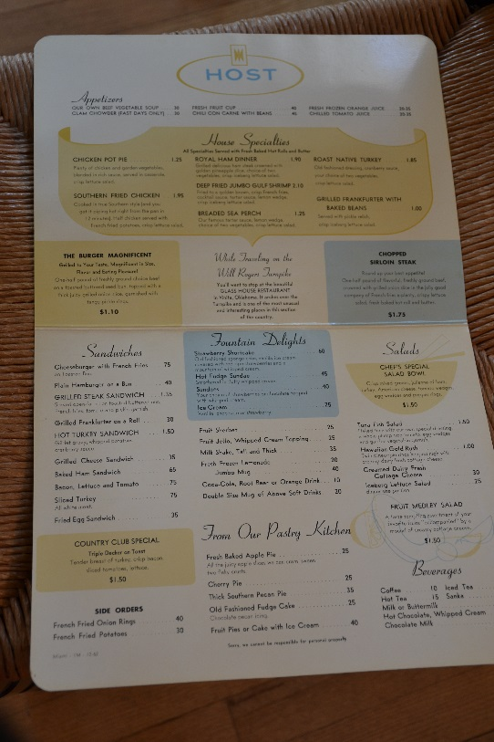

I loved the chicken pot pie. When we served the chicken pot pie it was a bowl with a pie crust, round pie crust on top of it. Then you carried it out on a plate. Of course we served the person’s food from the left. We served the drinks from the right, on their right hand. Now if they were in the booth because there was a row of booths on the one side of the dining room, if they were in a booth of course you reached across. When they were sitting at a table you always served their food from the left. We would sit that down and the chicken pot pie you would say, “Shall I serve you?” Usually they’d say, “Yes.” Then you use some sort of utensil that I can’t remember, to lift the crust off of the chicken pot pie and put on their plate. Then you were holding the little bowl, and then you would spoon the pot pie stuffing over the crust. Isn’t that fun? There were a lot of things that we served that were flamboyant like that. I like to think that that made it a special experience for them.

I think that Annabell wanted the Glass House dining room to be a separate experience. The Glass House had a snack bar that was open all night, and probably opened eight or nine o’clock in the evening, and was open all night to serve truckers or people that stopped at night. That was at one end of the—I believe it was on the south end of the Glass House. Then on the other end was the gift shop. On the northwest side, I guess you would call that—east side was the dining room. On the west side facing toward Tulsa was the cafeteria. Okay? So they were separated by a long hallway, and the hallway on one end was the snack bar and the other end was the gift shop. The dining room was the place that I worked and that’s where we were real waitresses compared to a waitress in the cafeteria, serving in a cafeteria line. Then the snack bar working as a waitress. I think probably most of us considered ourselves superior to them, (laughs) because we had the job in the dining room.

**Finchum** *Higher up the food chain.*

**Lewis** Yes, and so the name of the dining room was called the Broiler Room. So here is a Broiler Room menu. This doesn’t have a date on it, but it shows the chef’s feature for tonight was beef stroganoff. Boneless breast of chicken Mornay, now Mornay meant, if I’m not mistaken, is a sort of sauce, and it says that it was served on fresh broccoli with Mornay sauce and I think that was a cheese sauce. I’m not positive about Mornay sauce. The jumbo shrimp on this dinner menu was two dollars and sixty-five cents. Can you imagine? I think in this menu it was even less than that. Chunks of prime beef tenderloin and fresh mushroom caps, I remember that one, and it was served with blue cheese, melted blue cheese, and a baked potato. That was three fifty for tenderloin, can you imagine?

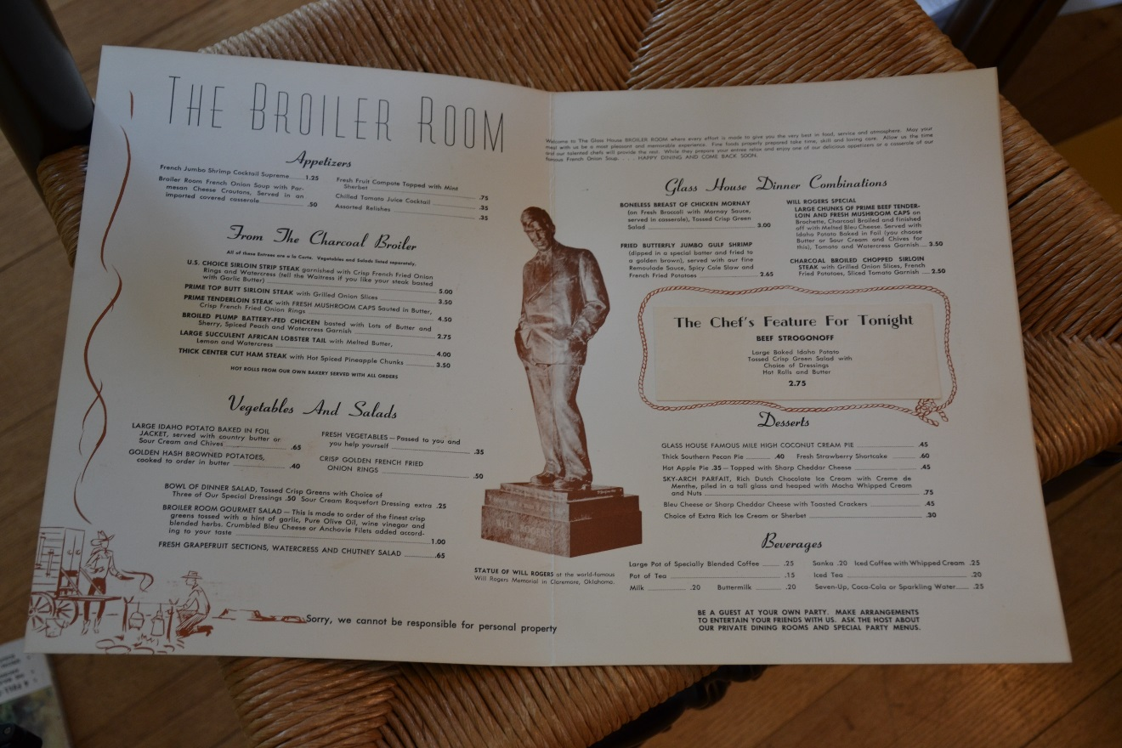

Then everyone who worked there in the Glass House dining room, when you talk to them and ask them, “What’s the one thing you remember that we served in the Glass House dining room?” They always remember the mile-high lemon pie. Now this one shows the mile-high coconut cream pie, and I don’t particularly remember the coconut cream pie. I remember this lemon pie. It was made as a tall pie to begin with. They mounded all of the filling up in the center. Where we would kind of level it off, they mounded it up in the center. This says, someplace I saw says that it was served with whipped cream. I really thought it was meringue. But then they topped that with whipped cream or meringue. So it stood up about that tall off the plate. (Gestures six inches) So when a waitress would come out to bring the mile-high lemon pie, to serve it, everybody would gasp and turn to look at it as you walked by. It was really exciting to serve! We had a parfait that was made with crème de mint, which is liquor. You know, it’s a liquor. I never did like it. I tried a little taste of it and it was pukey to me. I don’t know that that was on this—yes, right here.

**Finchum** *It was forty-five cents for the pie.*

**Lewis** Yes, for the pie. The parfait was seventy-five, rich Dutch chocolate ice cream with crème de mint, piled in a tall glass and heaped with mocha, whipped cream and nuts. Can’t you just imagine? We layered that. I thought that they made that in the kitchen, but the girl that you probably talked to first this morning, Edith Hicks, told me that the waitresses served that. That the ice cream was on the waitresses’ station and that we made that up and served that. That was really exciting to be able to serve this. Now look, here is a sirloin strip steak, five dollars.

**Finchum** *It had to be in the ’60s, early ’70s.*

**Lewis** Yes. I think this is probably one that we used.

**Finchum** *Do you know why they called it the Broiler Room?*

**Lewis** Yes, because there was a broiler that they cooked the steaks and the hamburgers on. The hamburgers, I believe I remember that they were like a half a pound of hamburger. I don’t see the hamburger on this menu. Maybe they didn’t serve the hamburger at night. Maybe they made you buy steak.

**Finchum** *Would you have to share your tips or did you get to keep them?*

**Lewis** No, we all kept our own tips, individual tips. I worked the summer of ’67, then I went to ORU for a year. Then I came back and as I said I didn’t get to go back to work at the Glass House that summer because I didn’t apply in time and she was already full. I worked at another restaurant. Then I got sick and didn’t get to go back to college at ORU the second year. That was kind of sad because I had scholarships. I had the whole second year paid for after I had scrimped and saved so hard for the first year. I didn’t get to go back.

It was five weeks or so that I was sick and not able and I missed too much class. So they saved my scholarships for second semester and then I started going with this first guy that I married and he didn’t want me to go off to Tulsa, he wanted me to stay in Vinita. So I turned down my scholarships for the second year, second semester at ORU and stayed in Vinita. By that time, in about September I went back to work at the Glass House, and I worked from September to about August the next year, that’d be ’69, at the Glass House.

In April I got married to Mr. Coleman. That’s when—I brought along the gift that Annabell gave me. I should’ve cleaned this up, but the silver buyers on EBay and places want the patina. They don’t want you to shine them up, they want the patina. So I left the patina on my dessert cup or candy dish. This is what Annabell gave me when I got married to Mr. Coleman. I was real impressed with her gift because she didn’t have to give me anything. I had a shower, I don’t remember Annabell coming to the shower, but I know that she gave me this gift. This is a Paul Revere Ware and it’s sterling silver. I have just treasured this over the years, that it came from Annabell. That was when I got married in ’69, and I worked then all that time.

In the fall of ’69 I got a chance to go to work at a furniture factory that had opened here in Vinita, so I worked there for a year. In 1970 in the fall semester we went to Okmulgee Tech School and we moved to Okmulgee. I was there seven years and then came back. By that time I was working at the phone company, of course, then. I would see Annabell around or we would be in clubs together and meet. I dearly loved her right up until the end. She was a really special person. One of the things that several people told me that she did, was that she gave jobs to kids, like in high school, that really she didn’t have a job open for them, but she would make work for them to do.

My husband said that he was making eighty-five cents an hour, I believe he said, working for Annabell. And in the spring when the college students were going to be coming back, he saw paper in the office that said she was hiring one of the boys from college at a dollar and a quarter an hour. He said, “Annabell, that’s not right. I’m working for you at eighty-five cents an hour and I’ve been with you for a year. This guy’s coming back from college and he’s been gone and you’re going to give him a dollar and a quarter an hour. Why is that?” She told Mike that it was because the college kids needed more money for their college. She made it a practice to support kids that were going off to college.

I’ve talked to several people in arranging these interviews that said that they worked five summers while they were going to college or they worked seven summers. That they always came back and worked for Annabell in the summer. Sometimes they’d come back and work Christmas break. At that time we didn’t have long spring breaks like we do now. We didn’t work spring breaks, but I know that I did work some for her that first year I was gone during my Christmas break, I had three weeks off I think. I worked a little bit during that time. She made it a practice to support the kids that were going off to college.

In going through the scrapbooks that Warren Fetter brought, I found lots of places where she had kept records of somebody graduating from OSU. There were several that she made sure that they got scholarships in food management. They went to…one man that went to OSU in food management and then graduated with his degree in food management. That’s in those scrapbooks that Annabell had put together. You can tell that she put those together chronologically instead of going back and putting them all in at one time. They are all spaced out according to when they happened. I really believe that she kept those scrapbooks up as she was going through. There were some of those people that were special to her.

Then one man, I’m sure you’ll be interviewing him, that when he went off to college then he was hired as the manager of the gift shop in the Cowboy Hall of Fame in Oklahoma City for a while. I don’t remember now who that was, but there was one of those men that I scheduled that worked at the Cowboy Hall of Fame.

**Finchum** *She touched a lot of people it sounds like.*

**Lewis** Yes, she did. Now Warren told me that he—I asked him what his job title was and he said that he was assistant manager here. He started out as a dishwasher, and busboy, and janitor, whatever. Then became the assistant manager and then he went off working for Host International in Indiana. He and Annabell set up an Indian village in Indiana somewhere that Host International owned. I thought that was real interesting, so you’ll have to be sure to ask him about that.

**Finchum** *When you were a waitress, let’s talk about your uniform.*

**Lewis** That was the hottest uniform and we didn’t, any of us, really like it. Now when I told people that I have some of those uniforms, two of those uniforms, they were thrilled to find that out. The gold is made out of nylon acetate and it would melt when you ironed it. So you had to iron it, if you did, with a very low heat. Then the aprons were made of heavy 100 percent cotton. We had to starch those and has the bib. Then we had a little headpiece that we wore. One of the girls told me that in early days they had a little tiny chef’s hat that they wore, but we didn’t wear those.

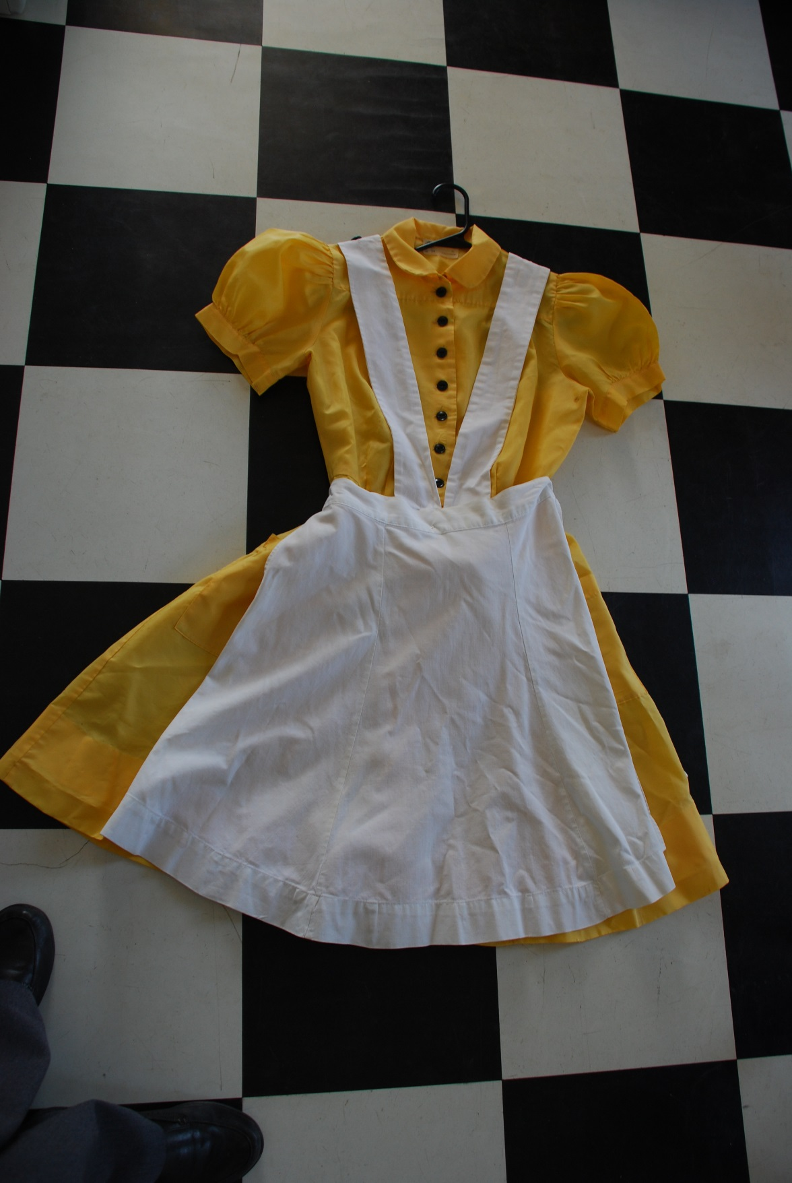

We had a big bow and it was just simply a square piece of material that you ironed out flat, then you gathered it in the middle and tied the ribbon around it, and then turned it into a bow and then you used a bobby pin to stick it in the back of your hair. I don’t have one today, but we wore those uniforms all the way closed at the neck and had a black ribbon that we tied into a bow around the neck too. Those were really special and everybody loves them, but we hated them when we had to wear them and iron them.

**Finchum** *And you had to keep it clean yourself, all that?*

**Lewis** Yes, we did all that our self.

**Finchum** *I notice there’s no pockets like for taking orders.*

**Lewis** In the orange uniform itself there is a pocket and we had our order books. I think I always probably had that in one hand and—one side, and tips in the other.

**Finchum** *What was considered a big tip?*

**Lewis** We frequently got a dollar tip. So I would think a couple of dollars was probably a really good tip. I worked mornings. Those girls that worked evenings I’m sure the reason I didn’t work evenings is that they wanted to work evenings, because if they were selling a steak for three fifty or five dollars then they were getting bigger tips than that. So they probably didn’t, any of them, want to give up their evening shift job, because that’s where the big bucks was. Someone told me that they remembered the girls folding their dollars in two and then bobby pinning them to their uniform bib, but I don’t believe that we ever did that.

By ’67 the Glass House had been open almost ten years, like nine years. In the scrapbook that I brought, the *Tulsa World* article about it is dated, I think, February of 1958 was when they opened. We Vinitans got where we took it for granted, but the Glass House is a nationally known location. I’ve been off at the telephone company schools and they’d say, “Where do you work? Where do you live?” I’d say, “Vinita, Oklahoma.” “Oh, that’s where the Glass House is.” Anybody that’s ever been up and down I-44, Will Rogers Turnpike, has passed the Glass House and knows where the Glass House is. We had a fine reputation.

I wanted to talk about these, a few of these postcards that I have. This is a picture of the inside of the dining room. Now I made a little note that that décor now is called mid-century modern. You know I watch “House Hunters” all the time and those, especially in California, they’re always looking for a mid-century modern home. They want a Frank Lloyd Wright home, you know. Frank Lloyd Wright was one of the one’s. Do you see the lighting? These were large windows, but they had louvers that shut so you could partially shut or completely close off the east windows when the bright sunlight was coming through. The west side would’ve been the cafeteria. The sunlight on the west side would’ve been shining on the cafeteria.

And you see in this picture it’s the, I don’t know if you can see those or not, but it shows the tables with tablecloths. I don’t believe that we served on tablecloths all the time, linen tablecloths. I believe that Sunday we always served on linen tablecloths and probably in the evening. Then this picture is a little different view and that shows the tables, individual tables showing.

**Finchum** *The windows look a little different.*

**Lewis** Yes, and now this is a picture of the cafeteria seating. I suppose maybe they got their own drinks when they went through the cafeteria line. That looks like a drink bar right there. Behind this right here would’ve been the cafeteria line they went through and were served. Now all these years I’ve told a misinformation about the cafeteria line, because I thought they made their eggs from powdered eggs and I never would eat them. (Laughs) But my husband told me “No, they weren’t powdered eggs.” There was one person that was in charge in the dining room, in the kitchen of breaking hundreds of eggs into giant vats, or pots, and scrambling them. Then they were served.

Now in the dining room eggs were cooked to order. The cook that worked the morning shift with me was a girl named Anita Wade—Webb, Anita Webb. She was the best breakfast cook I ever worked with. If you said you wanted easy-over eggs with the whites done, they came out perfectly every time. I took lessons from her and I’m real queasy about eggs. The white has to be done for me, but I like my yolks runny. If I can’t have it that way I want scrambled eggs, and I don’t want any whites showing in my scrambled eggs. They have to be totally yellow and cooked. They can’t be wet. I saw and watched her cooking eggs and she was an expert at it. I took lessons from her.

I remember her making the pancakes and that she would put the pancakes on the grill, then she flipped them over when they were ready to be turned over. She never flipped them a second time, because when you flip them a second time you knock the air out of them and they are heavy instead of being light and fluffy. That’s the way I cook my pancakes too. My kids used to always, every Saturday morning, want my pancakes. Of course I fudged on it a little bit by using Bisquick. I would always make mine thinner than the recipe called for, because I didn’t like them real thick, because then you have trouble getting the middle of the dough…it would turn out doughy in the middle if you didn’t get it completely cooked. It was thinner at the Glass House when she cooked them.

I can remember they used one of those big pots, which was probably about this tall, to make up the pancake batter and whatever was left they put back in the refrigerator and then added ingredients to it and added to it and made another batch again. I throw out any leftover pancake dough, course I never have any leftover, but I couldn’t imagine keeping it. But anyway, they kept it and it was refrigerated and it was very good.

Speaking of what we ate, my husband said that Annabell…they always talked about all these unusual foods and he said he would love to have a lobster. I don’t remember eating any unusual foods. My idea would’ve been that if we did eat them we just had to pay for it. If we got a T-bone steak we would just have to pay for it like a customer. My husband said that Annabell said, “I will cook you what you want to eat one time.” So he said, “I want a lobster.” So she personally cooked him a lobster to eat that one time. She said, “Now that’s all of the fancy food you get,” because she asked him what he wanted to eat that one time and he got lobster.

I made a little note that I always thought she favored the men. I think that she was nicer to the men than she was to the women. She was not—they still had to do their job. She did not favor them enough to let them get by with anything, because he told a story one guy was kind of having a nervous breakdown and couldn’t stand anything one night. He ran off down the turnpike, off the loading dock you know, and he said he went in to Annabell’s office and said, “Well there’s goes so-and-so down the turnpike.” He didn’t come back for fifteen minutes. She said, “Okay. That’s it.” I guess that was the second or third time that he’d kind of acted out. So she let him go. That’s the only person I ever heard of her ever letting go. I was so sorry that my husband would not come in and be interviewed.

**Finchum** *Did she have kids of her own?*

**Lewis** No. She had a niece and nephew that my husband and several people asked me about if I had contacted them. The girl’s name was Beth Anne, and there are pictures in the scrapbook taken of Beth Anne and one of the workers at the Glass House. I think that she came down in the summer and spent some time with Annabell several summers.

**Finchum**  *I wonder where she got her training, Annabell.*

**Lewis** You know I really don’t know. I know that she was assistant manager when it first opened, and I think it was two years later before she became the full manager. From what I read in the scrapbook and she was mentioned before too, there was a lady named Mrs. Kellow. They called her Kellog like a “g” on the end. In the scrapbook her name is spelled K-E-L-L-O-W, Kellow, okay? So she was the original manager. Then there were letters, there was a letter congratulating Annabell on becoming manager. So I guess Mrs. Kellow went on to Miami [Oklahoma] because I was told that she lived in Miami. I never did work with her, but she evidently was running the office, the dining room in Miami. I never did work with her.

I mentioned about the row of booths. The first booth right beside the hallway where we made our drinks and did all of our work as waitresses, was the coffee break booth. The men from the service station would come up and drink coffee with us. They were always so much fun. The highway patrolmen would stop and come up and have their breaks there too. So there were several highway patrol that we were well acquainted with back then. Mr. Hamilton was one that I knew really well. Course he passed away many years ago and there are several others. One of the men that worked in the service station was named Speedy Woolman and he has since passed away. He was one of the ones that was dressed in the Indian costume.

**Finchum** *His last name was what?*

**Lewis** Woolman.

**Finchum** *W-O-O-L-M-A-N.*

**Lewis** …M-A-N, yes. And there are still Woolman family in Vinita. I believe that Speedy’s daughter is the one that lives across from me, but that might be…her name—of course she’d married—but that might’ve been Speedy’s niece, his brother’s daughter. I think this might be Speedy Woolman dressed up in the Indian costume because he was one of the ones that dressed up in the Native costume. One of the other girls that you’re going to interview dressed as a Cherokee Indian girl. She will be interviewed, so I won’t tell her story. I mentioned that the Broiler Room was called that because of the big broiler. I don’t know if you can see that in one of these pictures. Go back to one of those dining room pictures.

**Finchum** *It looks like someone’s cooking.*

**Lewis** Over there, yes. The chef that worked that wore a tall hat. One of the pictures that has that girl in it, Donna Secondine Parker, is a man with a tall chef’s hat. I guess he worked the broiler in the evening. That was somewhat shaped like that and they broiled the meat on the broiler. So that was—and then right over on this side of that whole end was the morning cook grill, griddle you might call it, where hamburgers and pancakes, and things like that, were cooked.

Another thing about Anita cooking, I’ve been in a lot of restaurants that they cooked the eggs on the grill, but she did not. She cooked them in a stainless steel pan with butter. They were luscious and they would just slide right out of the pan. When she was ready to serve them, she’d just dump them out on a plate just as pretty as you please and set them up there ready to be served. It was a hard job.

Now one thing is that behind here, and I don’t know that we have any place that shows it, there was another dining area. Yes, I believe this is looking back toward it. You see that? There was another dining area back there and my junior and senior high banquet took place there at the Glass House. My senior year, I still have the little, I think it was a drink cup, but of course they didn’t serve us liquor. It said, “Senior Banquet.” They served oriental food and that was the first time I’d ever eaten oriental food, because they didn’t cook anything really oriental at the Hotel Vinita Coffee Shop. That was where banquets were held. A lot of people had their wedding receptions there or bridal showers. That was a room that was reserved to have banquets and things.

**Finchum** *Fancy place.*

**Lewis** Yes, it really was. Let me see if I’ve left anything out. So I got married there in 1969. Well, then I started going with Mr. Coleman and then we got married in ’69. We were married about seven years when we got a divorce. I moved back to Vinita and moved a mobile home next door to my mother and was driving to Tulsa.

My mother was in Kansas City one weekend on Saturday and a letter came from Mike Lewis, who was my high school sweetheart. I said, “There can only be one Mike Lewis writing to my mother,” and so I opened the letter. He was in the Army and he was going to be coming back to Vinita. So I wrote him back and told him, “Come on out.” He was asking where Bob and Lavon were. I said, “Bob is no more, we’re divorced. Come on out and I’ll have a party, get some of our old buddies together.” So I picked him up at the airport and it was once again love at first sight. Then he had to go to Germany for a year. I should have taken a leave from my job and gone to Germany with him, but I didn’t. I had almost ten years with the phone company and he had almost ten years in the Army. So he got out to marry me and then we had our career here in town. He always supported my career, but that was in 1980.

So he had been divorced, was divorced, and I was divorced and we resumed our relationship. It was really wonderful. It has been hard. You know you can have a romantic beginning, a romantic ending, but living the life for any marriage is hardship. I mean having to live with them, but we’ve had a wonderful time. So it’s thirty-six years this year and we have—I have a son by my first marriage, then we have a daughter together. Wouldn’t trade anything that I’ve lived through in all my life.

I believe that Annabell prepared me for my career with the phone company. I’m winning and benefiting from all of that today because I stayed with it. You couldn’t quit on Annabell. She did not want quitters. When you worked for Annabell you gave it everything you had and that’s what the telephone company required. You know it was a wonderful experience, and I know that having the relationship with Annabell and working at the Glass House prepared me for everything I’ve lived in life.

I had a good mother prepared me early, I had Mrs. Driskill who prepared me, and Annabell. Then of course I had a lot of people in the phone company who were my mentors too. It’s been a wonderful life. And now we are going to have a Glass House reunion at the end of August and I’m really looking forward to that. We’ve never had a Glass House reunion before. As far as I know there has never been one.

Now in the scrapbooks, in 1972 they had an employees’ party and she kept a lot of pictures and papers about that. She was an event planner, we didn’t call it that then, but she had menus written down with the recipes and who was to do what and where. They dressed up in costumes, it was around Halloween, they dressed up in costumes for Halloween, and they had people singing. The story about the leg bone? The foot bone connected to the ankle bone, that. “I Hear the Word of the Lord,” that song. She planned all of that event, so she was so talented. I think everybody that ever worked for her really loved her. She was a wonderful person to work for. You wouldn’t hear me saying this about some of my wonderful women bosses at the phone company. I had good bosses at the phone company, but I’m really being truthful about the way Annabell was, because she had an impact on everyone’s life. She was just so wonderful. She was rough, she expected you to do the job, so it wasn’t all candies and cream. It was work, but she was also fair. So I am so glad that I had that experience of being able to work at the phone company. So thank you for giving me this privilege of being interviewed. And I’m so glad I was able to do the contacting people…

**Finchum** *And arranging all of this.*

**Lewis** …arranging the—contacting people because I have had so much fun on the phone for hours with those people talking about the old days at the Glass House. I really hope that they remember to tell you some of those wonderful stories.

**Finchum** *If they don’t we’ll poke them again.*

**Lewis** Yes, one more thing about the…I said that they made everything that was served there. They also made all of these wonderful desserts. Southern pecan pie, that was my husband’s favorite and he said that he would cut a piece of the pecan pie before it ever left the bakery. They had a bakery, a dish room, inventory, storage—storeroom, you know, downstairs. Annabell’s office was down there. He said that pecan pie was one of his favorites. They had cherry pie and different kinds of cake.

I remember the strawberry shortcake and that the sponge cake was made there at the Glass House too. I’m one that have never—I have never liked the little sponge cakes that you buy. When you’ve ever had the real thing you just can’t really go with. I like angel food cake with strawberries, but it’s just not the same thing. Then my first mother-in-law was an absolute cook and she cooked biscuits. She’d cook a sweet biscuit and then cut that in half, great big biscuit, cut that in half and serve strawberries on that. I love it that way too.

And a strawberry pie made with gelatin where you cook your pie crust, you set your strawberries up with the pointed end up, and then you mix some more strawberries mixed, cut up and stirred up with cornstarch and sugar. It makes a sort of a jello and you pour that over your pie. Then that congeals around your fresh strawberries, and that’s an excellent one too. They served that out there too. That was a specialty also at the Hotel Vinita Coffee Shop. They were wonderful cooks. I don’t remember ever eating anything there that I did not like.

**Finchum** *Did the recipe survive?*

**Lewis** I found some recipes in the scrapbooks. I’m going to make copies of all of the pictures, scan them in, and I might send some of those if you’d like to have those. Warren did not give them to me, but I told him I wanted to scan them in and save that stuff on a computer. He said, “You can keep them as long as you need them,” and I think he’s going to donate them to Eastern Trails Museum.

**Finchum** *Good.*

**Lewis** I think the books themselves are falling apart, so I believe they will have to be rebound or reset in scrapbooks.

**Finchum** *Scan them before you redo them.*

**Lewis** Absolutely, yes absolutely.

**Finchum** *And the menus.*

**Lewis** And the menus, yes. I took pictures. These big menus are hard, but I did take pictures of them with my little iPhone in halves and posted those on a little group on Facebook. I’m really big on Facebook groups.

So it’s been wonderful talking to you, and I’m so glad that we had this opportunity, and I’m so glad that the Glass House is getting the recognition that it should have, because it is a major part of Oklahoma history.

**Finchum** *We appreciate all your work with this too. It’s made ours easy.*

**Lewis** Thank you, good, good. Thank you so much.

**------- *End of interview*** *-------*